Researcher Biography
Name: Tayne Ryall
Role: PhD Candidate
Institutional affiliation: University of Canberra
As a physiotherapist for over 15 years I have developed my passion for health professional education initially as a senior clinician supporting new graduates and university students, and now as a clinical educator in an acute care setting. I feel privileged to help guide students’ progression across their university degree from student to novice clinicians, especially the light bulb moments that occur on clinical placement when they are able to take the theory taught to them at university and put it into action in the real world setting.
The positive impact on the lives of the patients and families that health care professional students encounter across their careers makes me feel proud to have been a part of their learning journey. I aim to instil a sense of curiosity, a passion for learning, and a patient-centred approach in all students and healthcare professionals with whom I work. I have continued to build on my passion for education and my own life-long learning journey through completing my Master of Education (Health Professional Education), tutoring at University of Canberra, and now through my PhD research. My research is focusing on the use of simulation to train and assess physiotherapy students in the university setting.

Project Summary
Title; ‘Peer Patients’ for enhanced assessment of clinical skills.
Names of the research team: Tayne Ryall, Dr Elisabeth Preston, Dr Bernie Bissett
Institutional affiliations: University of Canberra
Contact details of the corresponding author: Tayne Ryall – tayne.ryall@canberra.edu.au
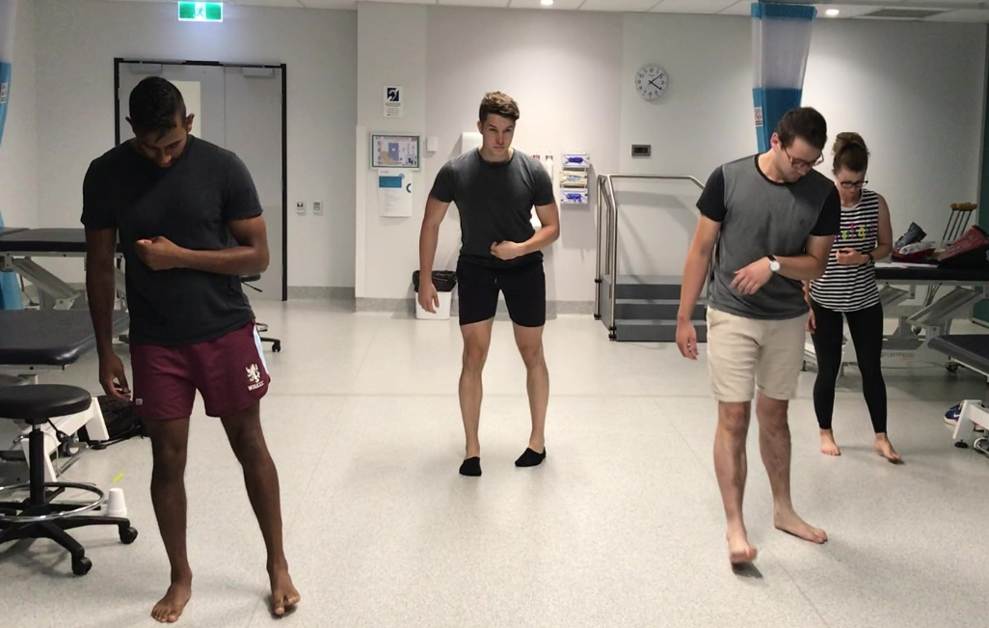

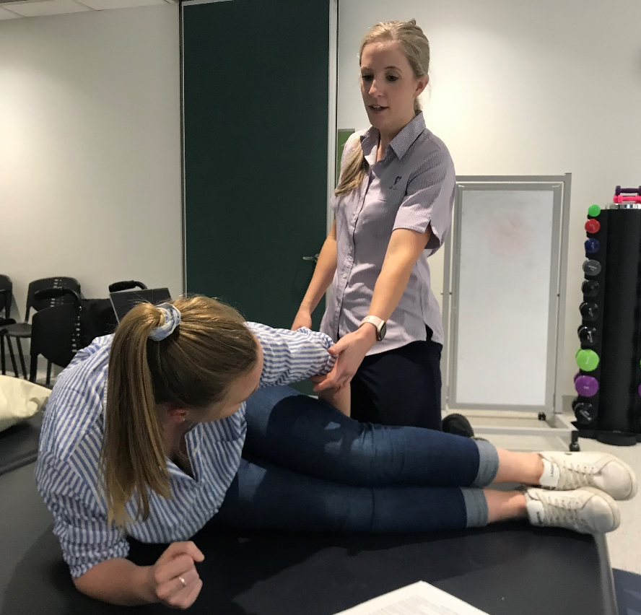

Take home messages: The ‘Peer Patient’ practical examinations have received positive feedback from both the third-year physiotherapy students undergoing the examinations and fourth-year students playing the role of the patient. The examiners have also noted that the examinations are more authentic and have allowed them to be more confident in their assessment of the third-year students.
Background:
The use and best form of simulation as an assessment tool requires further investigation in healthcare education (Ryall, Judd, & Gordon, 2016). ‘Peer Patient’ is a novel form of simulation developed by Western Sydney University and Monash University. Physiotherapy students undertake an online education package to train them to play the role of a patient for a peer to practise their clinical skills (peerpatient.com.au). ‘Peer Patients’ have been found to be feasible and realistic in classroom-based training of physiotherapy students (Pritchard et. al., poster presentation ANZAPHE 2019).
Our current study aims to investigate ‘Peer Patient’ methodology to train standardised patients for neurological physiotherapy practical examinations. Currently at University of Canberra, the third-year students undertake their practical examinations on one another. We hypothesise that by undertaking an examination where there is a “patient” with apparent impairments and activity limitations, instead of a typical healthy peer, the assessment of the student will be more indicative of future clinical performance.
Aim:
The aim of this research is to investigate the feasibility and reliability of ‘Peer Patients’ for student practical examinations in neurological physiotherapy curriculum and determine their ability to predict students’ performance on a rehabilitation clinical placement.
Study Design:
A feasibility study, using convenience sampling, concealed consent, and with quantitative and qualitative post-test measures with 80-100 third-year students will be undertaken at University of Canberra. All students enrolled in neurological physiotherapy across 2020 are eligible to participate, only those who consent will have their data analysed. However, all students will undergo ‘Peer Patient’ examinations. Eleven fourth-year physiotherapy students were recruited and trained using the ‘Peer Patient’ methodology. To allow for familiarisation with ‘Peer Patient’ simulation, one tutorial was allocated to 3rd year students’ practising with the ‘Peer Patients’ prior to examinations.
The predictive validity of the practical examination using ‘Peer Patient’s’ will be determined by examining third-year students’ ‘overall’ scores on their rehabilitation placements. A Pearson’s correlation coefficient and odds ratios will be calculated to determine any association. The ‘Peer Patients’’ consistency of patient portrayal will be assessed and examined using intraclass coefficients. Secondary outcomes will be an acceptability survey completed by the third-year students, training time of the ‘Peer Patients’, and any adverse events. Secondary outcomes will be presented using descriptive statistics.
Progress:
Four ‘Peer Patient’ examinations were to occur across 2020. However, due to changes to the curricula implemented in response to COVID-19, only the first and last for the 2020 cohort were run (with addition COVID-19 precautions). An ethics amendment was applied for and semi-structured interviews of a sample of the third-year and fourth-year students were undertaken. Transcription and thematic analysis is underway. Data collection will continue across 2021 as the third-year students complete their placements. Anecdotal evidence indicates both groups of students recommend continuing ‘Peer Patient’ examinations. Examiners have also reported acceptance stating that they feel they were able to assess students’ abilities in a more realistic way. Once analysis is complete, and if it proves supportive, it will be proposed that ‘Peer Patient’ examinations continue within the physiotherapy neurological curricula. An exploration of the use of ‘Peer Patient’ examinations within other physiotherapy and health disciplines’ curricula will be undertaken.

