Associate Professor Jo Bishop
ANZAHPE President
ANZAHPE Office
PO Box 852
RENMARK SA 5341
Tel: 0478 313 123
www.anzahpe.org
ABN 57 130 154 650

The following policy applies to the use of ANZAHPE resources:

Recordings produced for or by ANZAHPE:

ANZAHPE members are permitted to access and use audio or video recordings produced for or by ANZAHPE (e.g., ANZAHPE ONLINE recordings) for personal use only. ANZAHPE does not support recordings produced for or by ANZAHPE to be disseminated at other events or for viewing by non-members.

Resources produced for or by ANZAHPE:

ANZAHPE members can download and share written resources produced for or by ANZAHPE as long as the authors are appropriately credited. Resources produced for or by ANZAHPE cannot be changed in any way or be used commercially as per the Creative Commons License CC BY-NC-ND 4.0

Sincerely,

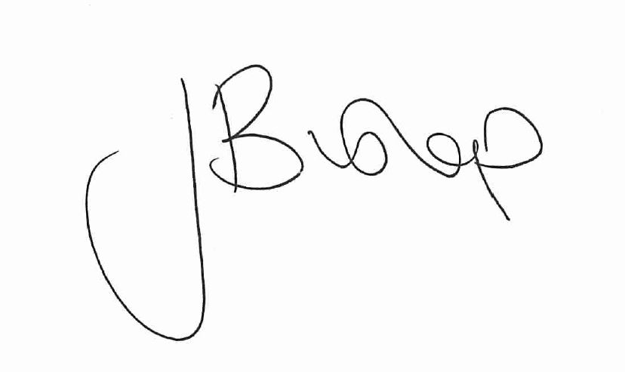

Associate Professor Jo Bishop
ANZAHPE President

