29 April, 2022

NOTICE OF AGM

The 2022 Annual General Meeting of ANZAHPE: Australian and New Zealand Association for Health Professional Educators will be held in virtual format on Monday June 27 at 1.00pm (AEST).
The link to attend the AGM will be forwarded on completion of registration to attend the meeting.

Please also refer to the Notice of Special Resolution and copy of the Objects and Rules.

A reminder to all: In order to vote at the AGM, members must be financial.

Please note that in the Rules of ANZAHPE Inc [24 (5)], corporate members shall have only one vote and must nominate in writing the person, or alternates, entitled to vote at the AGM. This nomination must be submitted to the Executive Officer at any time up to the commencement of the meeting.
We ask that all registrants who are attending under corporate membership subscriptions please clarify who will be entitled to vote on behalf of their organisation. Please contact the ANZAHPE office using the details on the top right of this letter to do so.

If members wish to appoint another member as proxy, the proxy details must be completed and forms forwarded to the Executive Officer no later than 48 hours prior to the meeting.

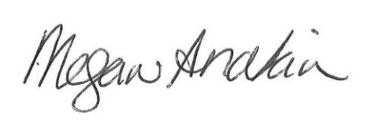

Megan Anakin
Honorary Secretary

